CANNAPATH
COMPLIANCE & REGULATORY SOLUTIONS

MINNESOTA CANNABIS COMPLIANCE
Your Guide to Passing the
Cannabis Cultivator
Pre-License Inspection

A Step-by-Step Readiness Workbook for Minnesota Cultivator Licensees
Aligned with the Minnesota Office of Cannabis Management (OCM)
VERSION 1.0
July 2026
Prepared by CannaPath Compliance & Regulatory Solutions
© 2026 CannaPath Compliance & Regulatory Solutions. All rights reserved.

What's Inside
What's Inside 2
Start Here 5
What the state is really checking 5
The road from application to open doors 6
Where to spend your energy first 7
What a cultivator licence actually lets you do 7
Where you sit on canopy 8
How to Use This Workbook 10
1 Who Owns and Controls the Business 11
What you need to have ready 11
2 Where Your Money Came From 12
What you need to show 12
3 Your Site and Location 13
What you need to have ready 13
4 Security, Cameras, and the Perimeter 14
The big pieces 14
5 Tracking Everything in Metrc 16
6 Your Written Procedures (SOPs) 17
7 Training Your Team 18
What makes staff fail the questioning 18
8 If You Grow: The Cultivation Plan Is the Real Document 19
Inputs, adulteration, and pollinators 19
Records that must survive five years 20
Growing medical and adult-use cannabis on one site 20
9 Sampling and Testing 21
10 What Access You Must Give the Office 22
11 What the Inspection Actually Looks Like 23
The four questions behind everything they do 23
How inspection day usually flows 23
The mistakes that fail inspections most often 23
12 Pre-License Inspection Field Checklist 25
12.1 Tax Status & Sales Restrictions 25
12.2 Facility & Property 25
12.3 Security & Access Control 26
12.4 Employees & Personnel 28
12.5 Operational Requirements 28
12.6 Manuals, SOPs & Recordkeeping 28
13 Run Your Own Practice Inspection 31
14 Common Reasons Applications Get Held Up 32
The two deadlines you cannot miss 32
15 What a Delay Actually Costs You 34
The fees, which are fixed and nonrefundable 34
Work out your own number 34
The math that matters 35
16 What Changed in the 2026 Legislative Session 36
Appendix A — Scored Readiness Assessment 40
A.1 Tax, Facility & Property 40
A.2 Security & Access Control 41
A.3 Personnel & Operations 43
A.4 SOPs, Records & Metrc 44
A.5 Workforce Training 45
A.6 Sampling & Testing 45
Appendix B — Mock Inspector Script 47
Layer 1 — Environmental Control 47
Layer 2 — System Independence 47
Layer 3 — Traceability Drill 47
Layer 4 — Staff Behavioural Audit 48
Layer 5 — Plan and SOP Integration 48
Appendix C — Evidence Request List 49
Appendix D — Corrective Action Plan 51
Finding Record 51
Appendix E — After-Action Report Template 53
Report Fields 53
Areas of Strength 53
Areas for Improvement 54
Domain Scorecard 54
Recommendations & Next Review 54
Important Notice & Disclaimer 55

Start Here
Why Most People Fail Before They Ever Open
Getting a Minnesota cannabis cultivator licence is not a paperwork contest. It is a test of whether your grow actually works — whether it can run as a controlled, lawful, traceable operation on the day an inspector walks the rows.
Most people who stumble do so for one reason: they focus on getting the licence instead of being ready to operate. They treat the pre-license inspection as a formality at the end, when it is actually the moment everything they have built gets tested. This workbook exists to flip that — to help you find and fix problems now, while they are cheap, instead of at the inspection, when they are expensive.
There is a particular trap in the cultivator licence. Most of what a cultivator is judged on is not a document you can produce on demand — it is a living plan. Your cultivation plan describes a specific layout, a specific canopy, specific inputs, and specific batch practices. The inspection tests whether the site in front of them matches the plan on file. Where those two diverge, the plan is what you will be held to.
By the time the state inspects you, you have usually already spent most of your money: the lease, the build-out, the security system, the staff, the first inputs. The inspection is the last gate before all of that becomes an operating, earning business. It is worth getting right.

What the state is really checking
The state is not grading your intentions. It is checking one thing: can this business operate, continuously, without product going missing or ending up where it should not? That breaks down into four questions that come up again and again.
What they check | In plain terms
Legal authority | Do you clearly have the right to conduct each activity here, under state law and local approval?
Control of the space | Do you really control a site that is set up to hold and handle cannabis securely?
Keeping it contained | Do your systems, procedures, and staff stop theft, loss, and unauthorised access?
A clear record | Can everything that happens be reconstructed later from your records alone?

Falling short on any one of these is usually enough to be held up — even if the other three are perfect. And here is the key insight: businesses do not fail on inspection day. They fail weeks earlier, when something gets written down or installed but never actually put into daily practice.
The most expensive misunderstanding in this whole process is thinking that a written policy checks the box. It does not. The state checks whether the thing actually works and whether you can show it on the spot. A camera that records but cannot pull up a clip, or a procedure your staff cannot actually follow, is treated as if it is not there at all.

The road from application to open doors
There are seven steps between applying and operating. Each one has a common place where people get stuck. Knowing the whole map helps you avoid the traps — especially the two short windows where you are given a limited number of days to fix a problem or ask the state to reconsider.
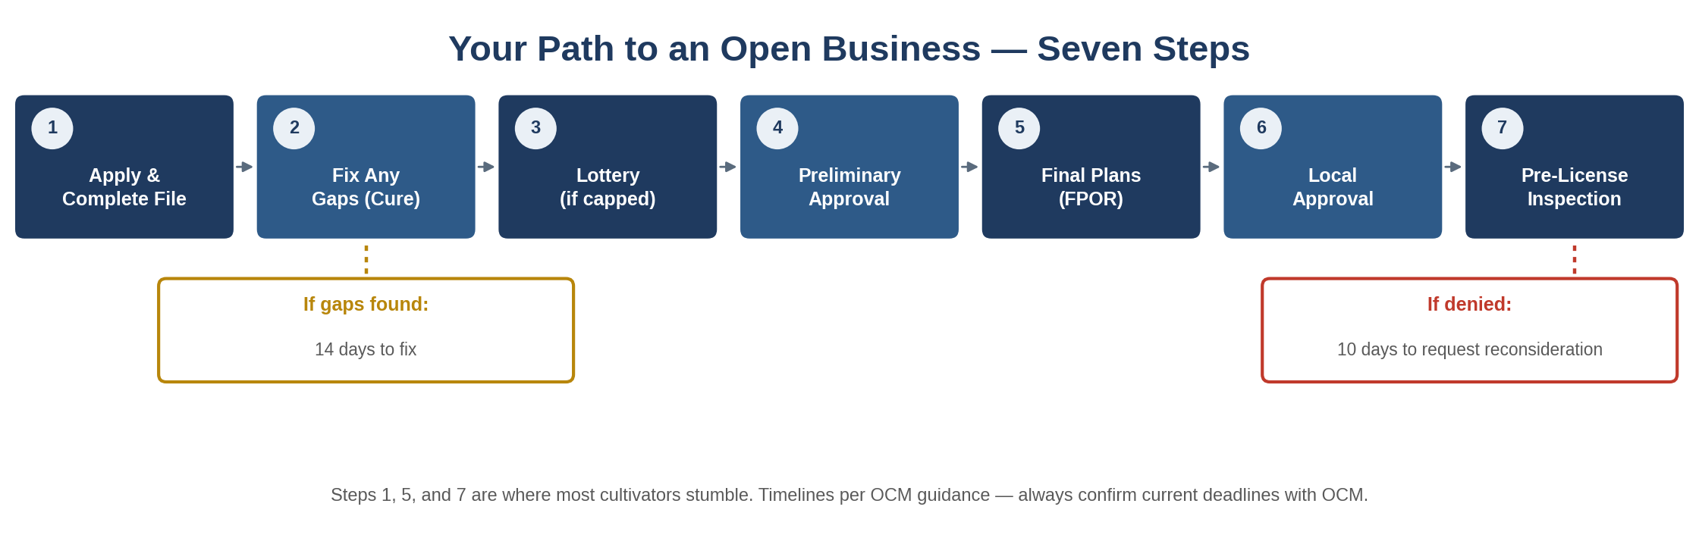
The seven steps to an operating business. The two boxes below the line are your only chances to recover if something goes wrong — and both are short.
A few things about this path are specific to your licence type and worth knowing before you start.
- You may also hold a cannabis manufacturer licence, a licence to grow industrial hemp, and a cannabis event organizer licence. [M.S. § 342.30, subd. 4(a)]
- Apart from those, you may not own or operate any other cannabis or hemp business. This does not prevent moving cannabis flower from your cultivator operation to a manufacturer licensed to the same owner on the same premises. [M.S. § 342.30, subd. 4(b)]
- OCM has authority to limit by rule how many cultivator licences one person or business may hold. [M.S. § 342.30, subd. 4(c)]

TWO TIMING FACTS WORTH PUTTING ON A CALENDAR NOW
Once you submit your site registration and final plans of record, OCM has 90 days to review your application. Incomplete final plans are the single most common cause of delay at this stage — if the plans are not fully complete you have to restart them, and OCM cannot schedule an inspection until plans are approved.
Preliminarily approved applicants have 18 months to complete steps 3 through 5. Under the 2026 cannabis law changes, that window can be extended by six months automatically upon request, and potentially by a second six months where the applicant is making good-faith efforts — up to an additional 12 months. Confirm the current extension process directly with OCM.

Where to spend your energy first
Not every requirement carries the same risk. Some are checked almost every time and hurt badly if they fail; others are minor. The map below sorts the big areas by how often the state checks them and how much damage a gap does. Start at the top-right — the red zone — and work down.
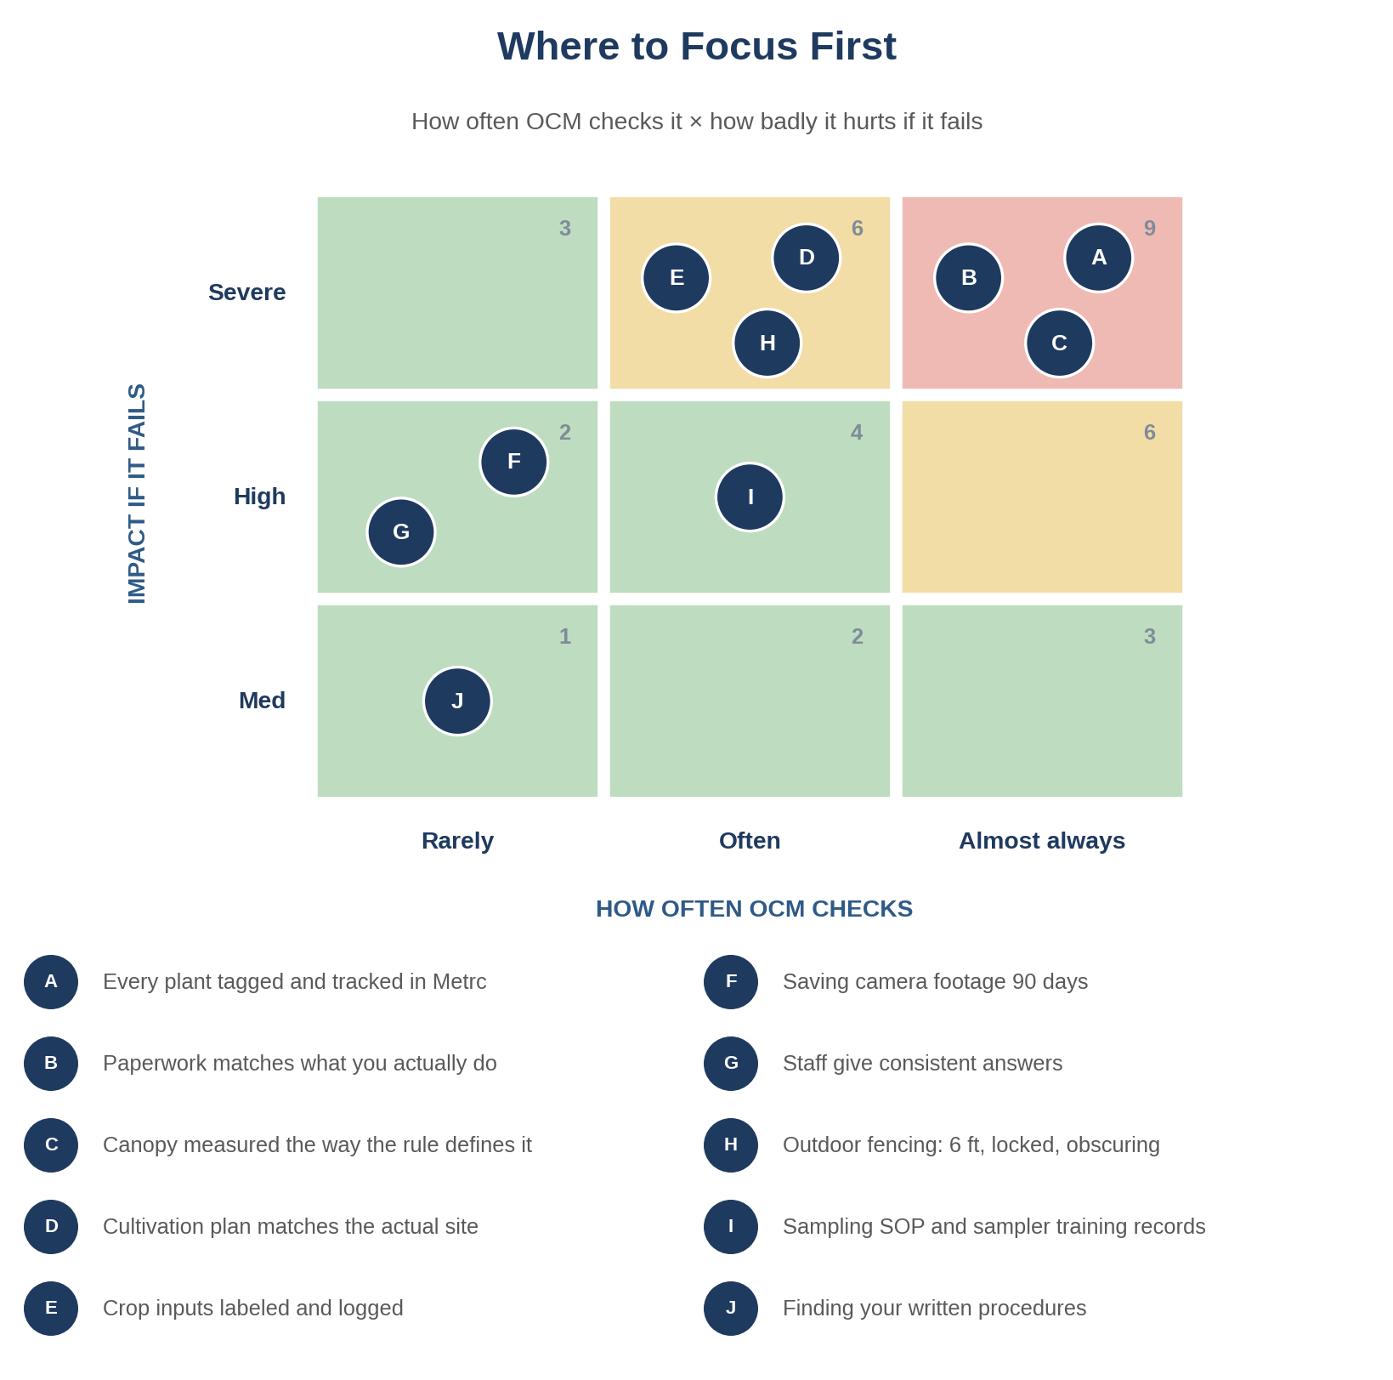
Where to focus. Anything in the red or amber zones should be solid before you schedule your inspection.

What a cultivator licence actually lets you do
A cultivator licence entitles you to grow cannabis plants within the approved amount of space from seed or immature plant to mature plant; harvest cannabis flower from a mature plant; package and label immature plants, seedlings, and cannabis flower for sale to other cannabis businesses; sell those to other cannabis businesses; transport cannabis flower to a cannabis manufacturer located on the same premises; and perform other actions approved by the office. [M.S. § 342.30, subd. 1]
Note what is not on that list: selling to consumers. A cultivator has no retail pathway. If you are planning to sell your own flower to the public, you are looking at the wrong licence.
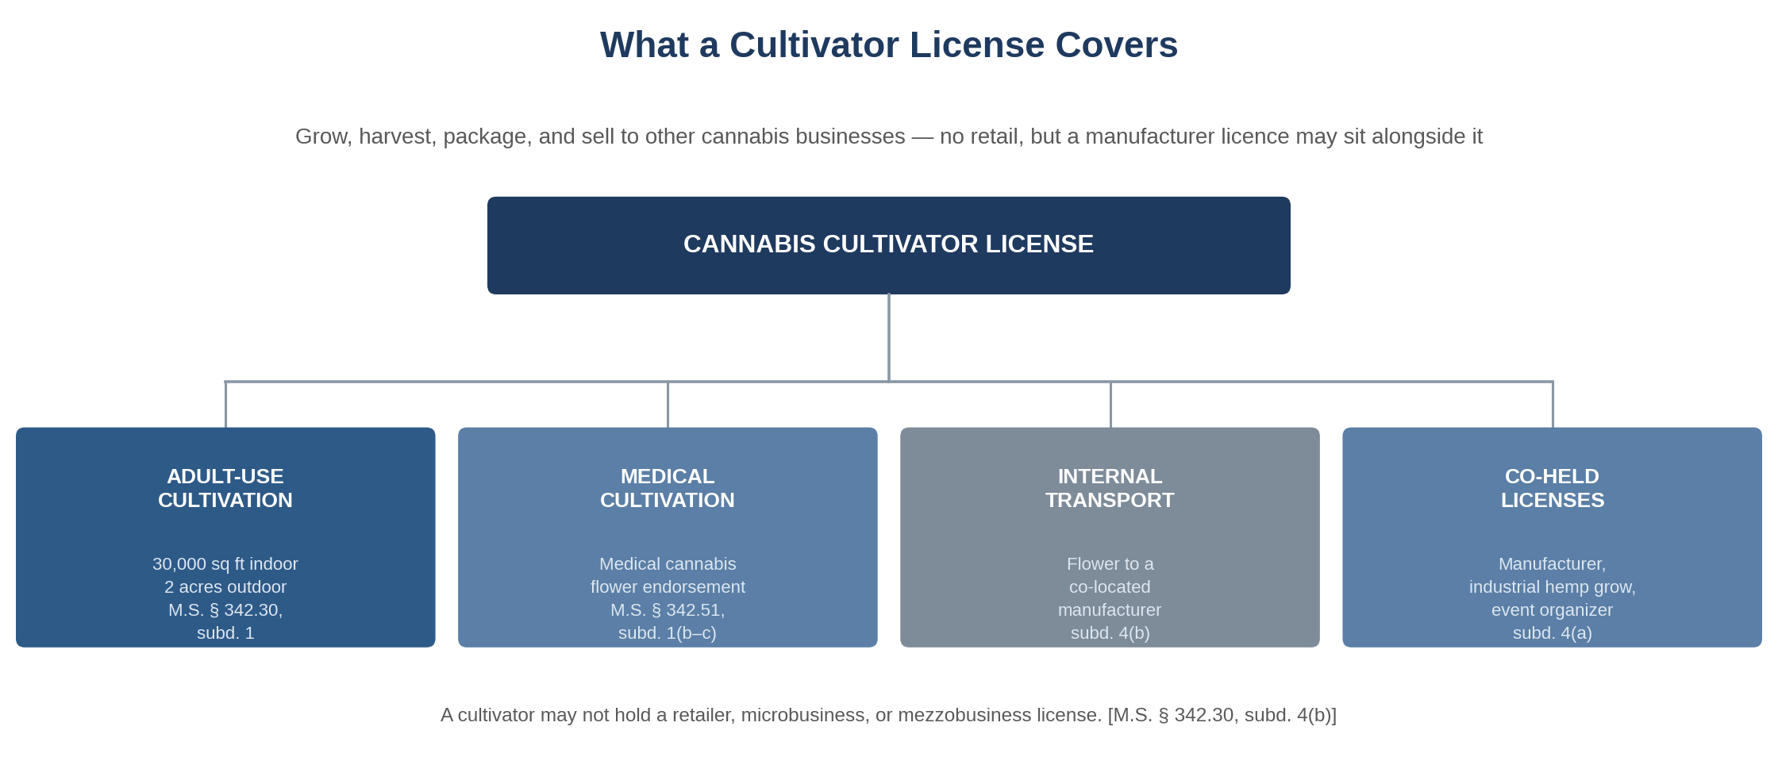
What sits under one cultivator licence. Each block below the line is a separate endorsement with its own inspection items.
Endorsement / activity | What it covers | Authority
Adult-use cultivation | Grow and harvest up to 30,000 square feet of indoor plant canopy or two acres of mature, flowering plants outdoors. | M.S. § 342.30, subds. 1–2; § 342.25
Medical cultivation endorsement | Cultivate cannabis for use as medical cannabis flower or in medical cannabinoid products. | M.S. § 342.51, subd. 1(b–c)
Internal transport | Move cannabis flower to a cannabis manufacturer located on the same premises and licensed to the same owner. | M.S. § 342.30, subds. 1(5), 4(b)
Co-held licences | A cultivator may also hold a cannabis manufacturer licence, an industrial hemp grow licence, and a cannabis event organizer licence. | M.S. § 342.30, subd. 4(a)

Where you sit on canopy
Canopy is the number the state will actually measure, and it is defined more precisely than most people expect. For a cultivator, the ceiling is 30,000 square feet of indoor plant canopy or two acres of mature, flowering plants outdoors. [M.S. § 342.30, subd. 2(a–b)]
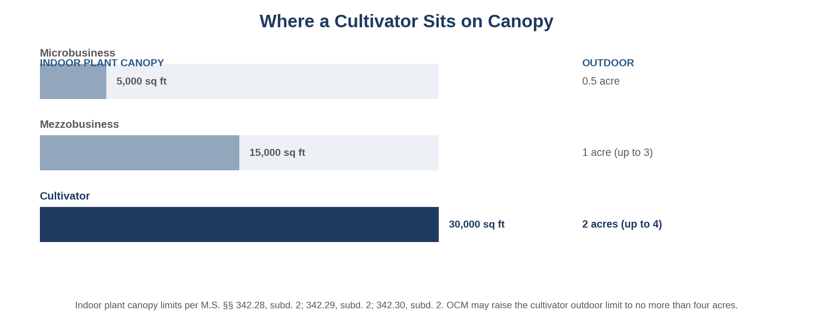
Canopy ceilings by licence type. These are the statutory limits; OCM may adjust them in a given licensing period.
Here is how the rule actually defines the measurement — this is where people get caught out:
- Indoor canopy is the total square footage of each distinct cultivation area containing mature, flowering cannabis plants. Distinct areas include trays, tables, and shelves, and may be demarcated by trellising, tiers, or other identifiable boundaries. [M.R. 9810.2000, subp. 4(A)]
- For outdoor mixed-light facilities — a greenhouse or hoophouse — the canopy acreage is the total area of the facility containing mature, flowering plants, minus any clearly demarcated walkways. [M.R. 9810.2000, subp. 4(B)]
- For fully outdoor cultivation, the canopy acreage is the total area of the field containing mature, flowering plants, minus vehicle access roads and completely fallow areas where no cultivation is occurring. [M.R. 9810.2000, subp. 4(C)]
- The total area in which cannabis plants are cultivated must never exceed the total area for which you are approved. [M.R. 9810.2000, subp. 6(B)]
WHAT THIS MEANS FOR YOU
Stacked or tiered growing is where most canopy miscalculations happen. If you run two tiers of flowering plants over the same floor footprint, that is two distinct cultivation areas, not one — the rule counts each tier. Measure your canopy the way 9810.2000, subp. 4 defines it, not the way your floor plan looks, and do it before you submit final plans.
Note also that the limit applies to mature, flowering plants. Veg, mothers, and clone areas are not canopy — but they are still part of the cultivation area you must identify in your plan.

How to Use This Workbook
This is a working document, not a reference book to read once and shelve. It is built to take you from “we signed a lease” to “we are ready for the inspector” — and to help you prove it.
Here is the simplest way to use it:
- Read the narrative sections once. They explain, in plain terms, what the state is really checking and why. Each ends with a “What this means for you” box that turns the rule into an action.
- Work through the field checklist at your site. That section is the actual list of things the inspector will look at, each tied to the state rule behind it. Walk your premises and check off what is real and demonstrable today.
- Score yourself in Appendix A. Rate every item from 1 to 5. Anything below a 5 is a to-do. Anything below a 3 on a critical item means you are not ready to schedule.
- Fix gaps using Appendix D. Write down each gap, who owns it, and when it will be done.
- Run a practice inspection using Appendix B. Have someone play the inspector. If you can pass your own practice run, you are ready for the real one.
WHAT THIS MEANS FOR YOU
You do not need to be a compliance expert to use this. If you can walk your site with this workbook and honestly answer “can I show this right now, without explaining?” for every item, you will know exactly where you stand.

1 Who Owns and Controls the Business
Before the state looks at your site, it looks at your paperwork — specifically, who really owns and controls the business. The goal is simple: the state wants to see, clearly, who is in charge of the money, the decisions, and compliance.
This trips people up more than almost anything else. It is not enough for your ownership documents to look clean. They have to match how the business actually runs. If the people truly making decisions or controlling the money are not named in your documents, that is a problem — even if everything is completely above board.

What you need to have ready
- Your business formation documents (LLC certificate, operating agreement, cooperative bylaws).
- A complete picture of who owns what — directly and indirectly — reconciled against your capitalization table.
- Any agreement that gives someone control or a financial stake: profit shares, loans, convertible notes, management agreements.
- The names of anyone who can veto a decision, control spending, or override operations — even if they do not appear on the ownership chart.
- Confirmation that no cooperative member, director, manager, or general partner holds an interest in a cannabis business other than the manufacturer, industrial hemp grow, or event organizer licences a cultivator is permitted to co-hold. [M.S. § 342.30, subd. 4]
WHAT THIS MEANS FOR YOU
Make a simple list: who controls the money, who makes the final call on operations, and who handles compliance? Then check that every one of those people shows up in your official documents. If someone is missing, fix the documents — do not hope it will not come up. The state will assume the way things actually work is the truth.
Pay particular attention to the single-licence restriction. It applies to the individuals, not just the entity. A silent partner with a stake in another licensee can disqualify your application even though your own business is clean.

2 Where Your Money Came From
The state is not judging how much money you have. It is checking that you can trace where it came from — cleanly, with documents, without needing to explain.
Think of it this way: a stranger should be able to follow your money from its origin all the way into your business bank account using nothing but your paperwork. If they would need you in the room to explain a transfer, that money looks untraceable — no matter how legitimate it really is.

What you need to show
- Where the money started — your own savings, an investor, a loan, a grant.
- How it moved into the business accounts.
- Any stops along the way, including transfers between accounts.
- Proof that the source is legitimate.
WHAT THIS MEANS FOR YOU
Build a simple money-trail document, written as if you will never be in the room to explain it. Every dollar funding the business should connect from its source to your business account with a paper record at each step. If you cannot draw that line cleanly today, that is your first homework item.
Keep it current. A capital call or a new investor after you submit changes the picture, and an updated capitalization table has to go in with your site registration.

3 Your Site and Location
A cultivator licence is tied to a specific site — not to your business in general. The state needs to see that you have real, exclusive control of a site that is properly zoned and physically set up for the activities you are endorsed to conduct.

What you need to have ready
- A signed lease or deed proving you control the space.
- Written confirmation from your city or county that your licensed activity is allowed at this location, and any conditional use permit your local government requires.
- Confirmation of whether your local government enforces building and fire codes — and if it does, evidence your site meets them.
- A certificate of occupancy, or one of the four permitted alternatives: a municipal waiver, a municipal letter saying no certificate is required, a municipality or third-party certifier letter confirming the building meets all codes, or an exemption under an “agricultural building” designation. [M.R. 9810.1100, subp. 6(B)]
- A floor plan or site plan showing clear separation between public areas, limited-access areas, and restricted-access areas.
Two structural rules catch people out. First, no licensed activity may be conducted in a dwelling — a home or residence. [M.R. 9810.1100, subp. 4] For cultivators specifically, all approved activity must occur in an area that can be reached without passing through a dwelling. [M.R. 9810.2000, subp. 8(A)] Second, there must be at least one toilet facility on the premises, in a completely enclosed room with a tight-fitting, self-closing door. [M.R. 9810.1100, subp. 6(A)]
WHAT THIS MEANS FOR YOU
Walk in your front door and look around as if you had never seen the place. Can someone wander from a public or general area into a space where regulated product sits? Is the line between “open” and “staff only” enforced by an actual locked door, or just a sign? Signs do not count as control. Physical barriers do.
Get your local government conversation done early and in writing. Zoning confirmation, code enforcement, and — if you are selling — retail registration availability are the three things that most often stall an otherwise ready applicant.

4 Security, Cameras, and the Perimeter
Security is the most detailed part of the inspection and the most expensive to get wrong after the fact. The state treats your security system as the thing that prevents theft and diversion — so it has to work on its own, automatically, even when nobody is paying attention.
The specific numbers are all listed with their exact rules in the field checklist later in this workbook. The key idea to understand now is this: it is not enough to have cameras installed. You have to be able to pull up specific footage, on demand, and match it to what happened. Footage you cannot retrieve is treated as if it does not exist.

The big pieces
- An alarm system, video surveillance, lighting, and locks — plus an immediate response protocol that starts within 30 minutes of a security event. [M.R. 9810.1500, subps. 1(A), 2(A)(1–5)]
- Cameras covering every area where cannabis is handled, plus all points of entry and exit, with at least 20 feet of clear recorded radius. [M.R. 9810.1500, subp. 9(C)–(D)]
- Footage kept at least 90 days, at 15 frames per second minimum, 720p minimum, date and time stamped, in a format that plays without proprietary software — and eight hours of recording through a power outage. [M.R. 9810.1500, subp. 9(E)–(F)]
- A locked product storage area posted with a sign reading “Restricted access. Authorized personnel only.” [M.R. 9810.1104, subp. 3]
- Commercial-grade locks on all external entrances and perimeter windows, and electronic locks with keypads on all perimeter entry doors. [M.R. 9810.1500, subp. 12]
- For any outdoor cultivation area: secure fencing and locked gates, at least six feet high, obscuring the area from being readily viewed from outside. [M.R. 9810.1500, subp. 15]
ALSO BINDING — NOT ALWAYS ASKED ON THE SPOT
Security measures are tested and inspected at least once every 90 days. [M.R. 9810.1500, subp. 3]
Alarm repairs are completed within 72 hours of failure, or operations cease until repaired (an extension may be requested from OCM). [M.R. 9810.1500, subp. 3]
Local law enforcement and OCM are notified of any alarm failure expected to last longer than eight hours, with alternative security measures implemented. [M.R. 9810.1500, subp. 8]
A record of individuals entering restricted areas is maintained for at least three years and made available to OCM on request. [M.R. 9810.1500, subp. 13]

WHAT THIS MEANS FOR YOU
Buy your security system from someone who knows the Minnesota cannabis rules specifically. Changing cameras or storage after you submit your final plans means going back to the state for approval. The most common mistake is a system that records fine but cannot quickly pull up a specific clip — make sure yours can, and practise doing it.
The 90-day testing cycle and the 72-hour alarm repair rule are not inspection-day questions, but they are binding from the moment you are licensed. Put both on a recurring calendar before you open.

5 Tracking Everything in Metrc
Minnesota uses a statewide monitoring system called Metrc. Every regulated item has to be traceable through it, from the moment it comes into existence to the moment it is sold, transferred, or destroyed. Metrc is not your internal inventory tool — it is the state's, and you are required to keep it accurate in real time.
For anyone with a cultivation endorsement, this starts earlier than most people expect. Every cannabis plant must be labelled with its batch number [M.R. 9810.2000, subp. 10], and your records must document the initiation of cultivation for each batch, the application of crop inputs, plant maintenance including culling and disposal, and the harvest date of each plant batch. [M.R. 9810.2000, subp. 13(A)]
Here is the test the inspector will actually run: they will point at one item and ask you to show its entire history — where it came from, everything that happened to it, and exactly where it is right now — using the system, on the spot.
You are also required to maintain a record of the names and log-in credentials of every Metrc system administrator and user who has had access within the past 12 months. [M.R. 9810.1301, subp. 8] That is a document, not a screen, and inspectors do ask for it.
WHAT THIS MEANS FOR YOU
Do not just set up Metrc — practise using it until pulling an item's full history is second nature. If you find yourself reaching for a spreadsheet or a paper file to fill in gaps, you are not ready. The whole point is that the system tells the complete story by itself.
Run the drill with the person who will actually be on shift, not with your most experienced operator. The inspector will ask whoever is standing there.

6 Your Written Procedures (SOPs)
SOPs — standard operating procedures — are your written rules for how the business runs. The state requires them, but having them written down is only half the job. The inspector wants to see that your team actually follows them.
The core SOP set that every licence type must have on site covers: accurate data entry into the statewide monitoring system; safe and sanitary storage; segregation and disposal of damaged, broken-seal, contaminated, expired, or recalled product; designation of authorised personnel and worker identification for restricted areas; designation of who may access and update private and nonpublic computer data; and security breach response consistent with Minnesota Statutes chapters 325E.61 and 325E.64. [M.R. 9810.1100, subp. 2(A)(4)–(9)]
Cultivators carry three more: worker safety procedures compliant with M.R. 9810.1102; procedures for providing representative samples for testing; and procedures for reporting all potential substances used during cultivating, manufacturing, and packaging to the statewide monitoring system for batch safety testing. [M.R. 9810.1100, subp. 2A(3), (10), (11)]
Everyone also needs written procedures for the consistent and accurate use of weighing and measuring equipment and for entering those weights into the statewide monitoring system. [M.R. 9810.1100, subp. 7]
The inspector may say something like, “Show me your procedure for X, and show me how you actually do it.” If the written rule and the real practice do not match, that is a serious problem — the most serious failure mode there is.
WHAT THIS MEANS FOR YOU
Write your procedures to match what your team will really do — not an ideal version nobody follows. A simple, honest procedure your staff actually uses beats a polished one they ignore. Keep them where staff can find them, and make sure everyone knows where that is.

7 Training Your Team
The state does not just want training certificates on file — it wants your staff to actually know what to do. Inspectors test this by asking your team questions directly, without warning.
Minnesota requires annual training for each cannabis worker, matched to that worker's role, authority, and responsibilities. The training must cover your SOPs, state and federal cannabis laws, state and federal data privacy and confidentiality law, the proper use of your security measures, emergency response for fire, power loss, robbery, natural disaster and workplace violence, and product recall procedures. [M.R. 9810.1102, subp. 2(B)(1)–(6)] You must keep records for each worker showing they completed it. [M.R. 9810.1102, subp. 2(D)]
Two more that are easy to miss: every worker must be given information about hazardous materials that may be present on the premises, and about procedures for safely handling and operating equipment or tools. [M.R. 9810.1102, subp. 3(C)–(D)]
Cultivators are also asked directly whether the business has an annual training plan — the plan itself, not just the records. [M.R. 9810.1100, subp. 2A(2)]

What makes staff fail the questioning
- Different staff give different answers to the same question.
- Staff have to go get a manager for basic compliance questions.
- Staff cannot explain who to tell when something goes wrong.
- Staff do something different from the written procedure when the inspector watches them work.
One hard line worth stating plainly: no employee under 21 years of age may have a scope of work involving the handling of cannabis plants, cannabis flower, artificially derived cannabinoids, or cannabinoid products. [M.S. § 342.24, subd. 1(a)] This is a yes-or-no inspection question and there is no discretion in it.
WHAT THIS MEANS FOR YOU
Run practice questions with your team before inspection day. Ask each person the same handful of questions separately — “What do you do if the count is off? If the alarm goes down? Who do you call first?” — and listen for consistent answers. If two people answer differently, train until they do not.

8 If You Grow: The Cultivation Plan Is the Real Document
For any licence with a cultivation endorsement, the cultivation plan is not a formality — it is the document you will be measured against. You may conduct only the activities OCM has approved in your submitted cultivation plan. [M.R. 9810.2000, subp. 2(B)]
Your cultivation plan must describe:
- The proposed size and layout of the areas used exclusively for cultivation, including a diagram indicating the total canopy [M.R. 9810.2000, subp. 3(A)(1)]
- A diagram of the proposed ventilation and air filtration systems [subp. 3(A)(2)]
- Plans for electricity, water, and other utilities [subp. 3(A)(3)]
- Plans for wastewater disposal and solid waste disposal [subp. 3(A)(4)]
- Plans for recycling supplies or environmental inputs, including water and packaging materials [subp. 3(A)(5)]
- A pest management protocol incorporating integrated pest management principles as defined in M.S. § 17.114, subd. 2(b) [subp. 3(A)(6)]
- Vendor name, vendor contact information, and invoices for all products intended for propagation — seeds, clones, fertilizers, nutrients, and chemical or biological pest control products [subp. 3(A)(7)]
- Procedures for operational record keeping that accurately identify all crop inputs entered into the statewide monitoring system and declared for laboratory testing [subp. 3(A)(8)]
- A description of the batch numbering you will use [subp. 3(A)(9)]
- Growing schedules including each seeding, planting, or cutting and propagation cycle date [subp. 3(A)(10)]
- Harvesting timelines and methods [subp. 3(A)(11)]
- Methods for drying, curing, and storing cannabis [subp. 3(A)(12)]
- A security plan as described in M.R. 9810.1500 [subp. 3(A)(13)]
THE TEN-DAY RULE PEOPLE FORGET
You must notify OCM of any change to your cultivation plan at least ten business days before implementing the change, on forms approved by the office and with all applicable fees. [M.R. 9810.2000, subp. 2(C)]
This means a layout change, a new nutrient line, a different propagation source, or a shift in drying method is not something you do first and document later. If the site does not match the plan on file at inspection, that gap is the finding — and “we were going to update it” is not an answer.

Inputs, adulteration, and pollinators
Crop inputs have to be handled and applied so they do not contaminate plants with filth, residues, or anything else that would render the product injurious to human health; must comply with Minnesota Statutes chapters 18B, 18C, and 18D; must be stored in original containers with labels intact or in properly labelled working containers; and must be documented in the statewide monitoring system. [M.R. 9810.2000, subp. 11(A)(1)–(4)]
Two prohibitions carry real weight. You must not apply pesticides when pollinators are present, or allow pesticides to drift to flowering plants attractive to pollinators. [M.S. § 342.25, subd. 5(b)] And you must not treat or adulterate cannabis plants or flower with any substance that has the effect or intent of altering the colour, appearance, weight, potency, or odour of the cannabis. [M.S. § 342.25, subd. 6]

Records that must survive five years
A cultivation record must be prepared for each batch of cannabis plants and cannabis flower and maintained for at least five years. It must include the quantity and timing of each pesticide, fertilizer, soil amendment, or plant amendment used to cultivate the batch. You must present cultivation records to OCM, the commissioner of agriculture, or the commissioner of health on request. [M.S. § 342.25, subd. 2]
Your per-batch records must also capture the date a worker conducted cultivation, the name of the worker or responsible worker, the specific cultivation activity performed, the batch number, and a description of the area where the work was done. [M.R. 9810.2000, subp. 13(B)]
One sourcing rule with a hard date: after December 1, 2025, cannabis seeds, immature plants, mother plants, and other propagative sources must come from a source authorised by OCM to sell those products. [M.R. 9810.2000, subp. 9(A)] Volunteer cannabis plants must be destroyed or disposed of using an approved method. [M.R. 9810.2000, subp. 9(B)]

Growing medical and adult-use cannabis on one site
If you hold both, you may cultivate them on the same premises only if your cultivation plan addresses both and you hold a valid medical cannabis endorsement. [M.R. 9810.2000, subp. 14(A)] From there the separation requirements are strict: cultivate medical cannabis in an area separated from adult-use; track it separately; store it separately; never cultivate the two simultaneously on the same piece of equipment; and keep an equipment log recording the worker, the tracking information for what was processed, the date, time and duration of use, and the tracking information for the resulting product. [M.R. 9810.2000, subp. 14(B)(1)–(5)]
WHAT THIS MEANS FOR YOU
Print your cultivation plan and walk the site against it, room by room, before you schedule anything. The inspector is doing exactly that. Where the plan says one thing and the room says another, decide now whether to change the room or file a plan amendment — and remember the amendment needs ten business days.
Keep the crop-input paper trail in one place: vendor invoices, labels, application weights and concentrations, and the Metrc entries. Reconstructing it later from memory is not possible, and it is a five-year retention obligation.

9 Sampling and Testing
Cultivators carry a sampling obligation that other licence types do not, and it is checked in detail. You need an SOP describing how to collect a representative sample for each regulated product. [M.R. 9810.1100, subp. 2A(10)]
That sampling SOP must:
- Address all requirements for sample and data collection and laboratory analysis. [M.R. 9810.3100, subp. 3A(1)]
- Contain the details necessary for accurate and consistent actions by assigned staff. [M.R. 9810.3100, subp. 3A(2)]
- Describe all processes for supervisors to verify that sample collection procedures are completed accurately by staff. [M.R. 9810.3100, subp. 3A(3)]
Records for training of staff conducting sampling activities or sample testing must be maintained for three years. [M.R. 9810.3100, subp. 3B]
Separately, you must report all potential substances used during cultivating, manufacturing, and packaging processes to the statewide monitoring system for batch safety testing. [M.R. 9810.1100, subp. 2A(11)]
SELF-TRANSPORT OF COMPLIANCE SAMPLES
Under the 2026 cannabis law changes, licence holders may transport a sample of their product to a testing facility without contracting a licensed cannabis transporter, through February 1, 2029, provided they meet certain requirements. OCM has published a Vehicle Disclosure Form for this purpose under guidance memo GM-2025-06. Confirm the current requirements with OCM before relying on this.

WHAT THIS MEANS FOR YOU
Write the sampling SOP so a new grower could follow it without you. The rule asks specifically for enough detail for consistent action by assigned staff and for a supervisor verification step — those two elements are what inspectors look for, and generic sampling language does not contain either.

10 What Access You Must Give the Office
A cultivator's obligation to give OCM access is broader than most licence types, and it is worth knowing before the inspector arrives so that nothing reads as obstruction.
You must provide access to:
- All areas where cannabis plants are growing or being harvested. [M.R. 9810.2000, subp. 5(A)(1)]
- All land, buildings, and other structures used for cultivating, handling, producing, and storing cannabis plants. [M.R. 9810.2000, subp. 5(A)(2)]
- All locations identified in your licence application, business plan, and cultivation plan. [M.R. 9810.2000, subp. 5(A)(3)]
- All records related to the production and propagation of cannabis plants, including trimming, culling, pest scouting and control, sampling, and testing reports. [M.R. 9810.2000, subp. 5(A)(4)]
You must also allow OCM to collect cannabis plant and cannabis flower for laboratory analysis to establish compliance, and provide that material at no cost. [M.R. 9810.2000, subp. 5(B)]
WHAT THIS MEANS FOR YOU
Brief whoever is on site that day. An inspector being told to wait for the owner before entering a drying room is a bad start to an inspection that has not begun yet. Decide in advance who escorts, what they can open, and where the records live.

11 What the Inspection Actually Looks Like
The pre-license inspection is the last gate before you can operate. It is not a paperwork review — it is a test of whether your business actually works as a controlled, lawful cannabis operation on the day they walk in.
OCM schedules the inspection after local government approval is received and your final plans of record are approved. The inspector is not following a simple yes/no checklist in front of you. They test your site by poking at it: picking random items, asking staff surprise questions, pulling up live camera and inventory screens, and walking your control boundaries. They are looking for any gap between what your paperwork says, what your systems do, and what your staff actually does.

The four questions behind everything they do
What they are really asking | What it is about
Can this site keep people out of restricted areas on its own? | Security
Can you account for every plant and product at any moment? | Tracking
Can your staff do their jobs correctly while being watched? | Your team
Can everything be reconstructed from your records alone? | Records

If answering any of these requires you to explain, interpret, or make an excuse, the inspector treats that control as incomplete.

How inspection day usually flows
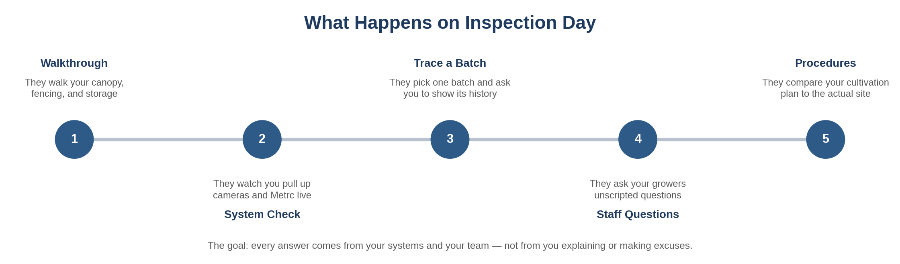
The five things that typically happen during a pre-license inspection.

The mistakes that fail inspections most often
The mistake | What it looks like | How bad
Systems that cannot stand alone | You have the system, but you have to explain or interpret it to make it produce an answer. | HIGH
Staff do not follow the rules | Your team does something different from your written procedures when watched. | HIGH
Systems do not talk to each other | Cameras, inventory, and access logs each work alone but cannot be tied together. | HIGH
The plan does not match the site | Your cultivation, manufacturing, or operating plan describes something different from what is actually built. | CRITICAL
Paperwork does not match reality | Your written procedures describe something different from what actually happens. | CRITICAL
Hidden gaps in access control | Someone can get into a restricted area without the system noticing. | CRITICAL

WHAT THIS MEANS FOR YOU
Here is the single most useful way to prepare: walk your site and try to fail each item yourself. Pull a random item and trace it. Ask a new hire a surprise question. Try to get into a restricted area without triggering anything. The gaps you find on your own are the ones the inspector will not get to find.

12 Pre-License Inspection Field Checklist
The Real Inspection List — Cannabis Cultivator
This is the list. These are the actual items the inspector will look at during your pre-license inspection, grouped the way the rest of this workbook is. Each one shows the exact Minnesota rule behind it (M.R. = Minnesota Rules chapter 9810; M.S. = Minnesota Statutes chapter 342), so if you ever want to read the source or show it to your attorney, you can.
IMPORTANT
This checklist is derived from OCM's published Cannabis Cultivator Pre-License Inspection List (updated 5/19/2026) and the underlying rules and statutes. As OCM itself states, the list of items subject to inspection may not be exhaustive, and the office is authorised to inspect the entire premises of a cannabis business.
Not all questions will apply. Requirements vary based on which endorsements and activity types you selected in your application. Citations and regulatory timelines are current as of the date of this manual and must be verified directly with OCM before reliance.

How to use this list. Walk your site with this in hand. For each item, ask yourself: “Can I show this right now, without explaining or making excuses?” If yes, check it off. If you have to talk your way through it, it is not ready yet — put it on your fix-it list (Appendix D). The rule reference is in brackets after each item.

12.1 Tax Status & Sales Restrictions
- The license holder is not included on the most recent monthly Minnesota Department of Revenue notice for “Posting of Tax Delinquency.” [M.S. § 270C.726, subd. 1]
- The business has a method to ensure it does not make sales or deliveries to another licensee included on the most recent Department of Revenue tax-delinquency posting. [M.S. § 270C.726, subd. 2]

12.2 Facility & Property
- The building has a certificate of occupancy. If it does not, one of the following is true: the municipality has waived the requirement; the applicant holds a letter or certification from the municipality that a certificate is not required; the applicant holds a letter or certification from the municipality or a third-party certifier that the building meets all codes; or the building is exempt under an “agricultural building” designation. [M.R. 9810.1100, subp. 6(B)]
- At least one toilet facility is located on the premises in a completely enclosed room with a tight-fitting, self-closing door. [M.R. 9810.1100, subp. 6(A)]
- The product storage area allows regulated products to be stored at least six inches above the ground. [M.R. 9810.1104, subp. 2]
- The product storage area is clean, well ventilated, and free from condensation, sewage, dust, dirt, pests, chemicals, and other contaminants. [M.R. 9810.1104, subp. 2]
- Hand-washing facilities have a hot and cold water supply. [M.R. 9810.2102, subp. 10(A)(2)(a)]
- Hand-washing facilities include soap and paper towels, sanitary towel service, or an electric hand dryer. [M.R. 9810.2102, subp. 10(A)(2)(b–c)]
- A ventilation and air-handling system provides humidity and temperature controls adequate for safe processing and sanitary operations. [M.R. 9810.2102, subp. 6(A)(3)]
Product storage
- The product storage area is locked. [M.R. 9810.1104, subp. 3]
- The product storage area has a posted sign at the entrance stating “Restricted access. Authorized personnel only.” [M.R. 9810.1104, subp. 3]

12.3 Security & Access Control

Security plan and protective measures
- Security at the premises includes, at minimum, an alarm system, video surveillance, lighting, and locks, plus an immediate response protocol initiated within 30 minutes after a security event occurs. [M.R. 9810.1500, subps. 1(A), 2(A)(1–5)]
- Effective security measures guard against product theft. [M.R. 9810.1500, subp. 5(A)]
- Effective security measures guard against product diversion. [M.R. 9810.1500, subp. 5(B)]
- Effective security measures guard against unauthorized access to the premises. [M.R. 9810.1500, subp. 7(A)]
- Effective security measures guard against unauthorized access to motor vehicles used in the transport or delivery of cannabis or cannabis products. [M.R. 9810.1500, subp. 7(B)]
- Effective security measures guard against unauthorized access to electronic business and customer records created and maintained by the business. [M.R. 9810.1500, subp. 7(C)]
- Effective security measures guard against unauthorized access to paper records created and maintained by the business. [M.R. 9810.1500, subp. 7(D)]

Alarm system
- The alarm system is in good working order. [M.R. 9810.1500, subp. 8(A)]
- The alarm system is active 24 hours per day, seven days per week. [M.R. 9810.1500, subp. 8(A)]
- The alarm system is monitored by a contracted security company or a worker employed by the business. [M.R. 9810.1500, subp. 8(A)]
- The alarm provides immediate alerts to the business and local law enforcement for any unauthorized breach of the premises or a system failure. [M.R. 9810.1500, subp. 8(A)(1)]
- The alarm provides immediate alerts to the business and local law enforcement for any hazardous conditions detected on the premises. [M.R. 9810.1500, subp. 8(A)(2)]
- The alarm has a backup system that activates immediately and automatically upon loss of electricity and alerts authorized personnel of the loss. [M.R. 9810.1500, subp. 8(A)(3)]
- The alarm includes an audible alarm capable of being heard by an individual within a 100-foot radius of entrances and exits. [M.R. 9810.1500, subp. 8(A)(4)]
- The audible alarm can be remotely disabled by authorized personnel. [M.R. 9810.1500, subp. 8(A)(5)]

Video surveillance
- An operational video surveillance system is present on the premises. [M.R. 9810.1500, subp. 9(A)]
- The surveillance system is active 24 hours per day, seven days per week. [M.R. 9810.1500, subp. 9(B)]
- Cameras are placed to allow clear recording of activity within a radius of at least 20 feet from all points of entry and exit. [M.R. 9810.1500, subp. 9(C)(1)]
- Cameras are affixed to the exterior and interior of the premises to identify individuals entering and exiting the premises, limited-access areas, and restricted-access areas. [M.R. 9810.1500, subp. 9(C)(2)]
- The system allows viewing of all areas where cannabis is cultivated, manufactured, stored, packaged and labeled, prepared for transfer, displayed, sold, where samples are collected, or where waste is destroyed or made unusable. [M.R. 9810.1500, subp. 9(D)]
- Video files are stored in a secure place for a minimum of 90 days. [M.R. 9810.1500, subp. 9(E)(1)]
- Cameras record at a minimum of 15 frames per second. [M.R. 9810.1500, subp. 9(E)(2)]
- Cameras have a minimum resolution of 720p. [M.R. 9810.1500, subp. 9(E)(3)]
- All recordings carry date and time stamps. [M.R. 9810.1500, subp. 9(E)(4)]
- Cameras can continue recording for an additional eight hours during a power outage. [M.R. 9810.1500, subp. 9(E)(5)]
- Recordings are saved in an industry-standard file format that can be played without the purchase of particular software or equipment. [M.R. 9810.1500, subp. 9(F)(2)]

Lighting, locks, and perimeter
- Fully functioning lighting is present in the interior and exterior of the premises. [M.R. 9810.1500, subp. 10]
- Lighting permits observers to see, and cameras to record, any activity within a radius of at least 20 feet around all entrances and exits. [M.R. 9810.1500, subp. 10]
- All external entrances and perimeter windows are in good condition, verified by visual inspection inside and out. [M.R. 9810.1500, subp. 12]
- All external entrances and perimeter windows are lockable with commercial-grade locks. [M.R. 9810.1500, subp. 12]
- All perimeter entry doors have electronic locks and keypads. [M.R. 9810.1500, subp. 12]

Outdoor cultivation areas
- Any outdoor cultivation areas are enclosed by secure fencing and locked gates. [M.R. 9810.1500, subp. 15]
- Any outdoor cultivation areas are enclosed by fencing that is at least six feet high. [M.R. 9810.1500, subp. 15]
- Any outdoor cultivation areas are enclosed by fencing that obscures — or have a cover that obscures — the fenced area from being readily viewed from outside the fenced area. [M.R. 9810.1500, subp. 15]
ALSO REQUIRED — NOT ALWAYS ASKED ON THE SPOT
The following duties are not phrased as on-site inspection questions but are binding under the same rule and bear directly on whether a security system is “operational” at inspection:
• Security measures are tested and inspected at least once every 90 days. [M.R. 9810.1500, subp. 3]
• Alarm repairs are completed within 72 hours of failure, or operations cease until repaired (an extension may be requested from OCM). [M.R. 9810.1500, subp. 3]
• Local law enforcement and OCM are notified of any alarm failure expected to last longer than eight hours, with alternative security measures implemented. [M.R. 9810.1500, subp. 8]
• A record of individuals entering restricted areas is maintained for at least three years and made available to OCM on request. [M.R. 9810.1500, subp. 13]

12.4 Employees & Personnel
- No employee under 21 years of age has a scope of work involving the handling of cannabis plants, cannabis flower, artificially derived cannabinoids, or cannabinoid products. [M.S. § 342.24, subd. 1(a)]
- The business has an annual training plan. [M.R. 9810.1100, subp. 2A(2)]

12.5 Operational Requirements
- No licensed activity is conducted in a dwelling (home or residence). [M.R. 9810.1100, subp. 4]
- The business has a measuring device or equipment (scale). [M.R. 9810.1100, subp. 7]
- All weighing and measuring equipment is maintained in a sanitary manner that does not contaminate any products. [M.R. 9810.1100, subp. 7]
- All electrical equipment, including grow lights, cultivation equipment, and packaging equipment, is suitable for the intended use. [M.R. 9810.2000, subp. 8(C)]
- Each production and cultivation area allows authorized individuals unobstructed access to, observation of, and the ability to conduct an inventory of all plant canopy. [M.R. 9810.2000, subp. 8(D)]
- Crop inputs are stored in their original containers with original labels intact, or in working containers of diluted or prepared applications labeled with the information required by Minnesota Statutes, chapters 18B, 18C, and 18D. [M.R. 9810.2000, subp. 11(A)(3)]
- If the business cultivates adult-use and medical cannabis on the same premises, the cultivation areas are separate from one another. [M.R. 9810.2000, subp. 14(B)(1)]
- The business's total plant canopy is 30,000 square feet (or two acres) or less. [M.S. § 342.30, subd. 2]

12.6 Manuals, SOPs & Recordkeeping
The business maintains, and can produce on site, standard operating procedures covering each of the following.
- SOP: worker safety procedures compliant with Minnesota Rules, part 9810.1102. [M.R. 9810.1100, subp. 2A(3)]
- SOP: creation and entry of accurate data in the statewide monitoring system. [M.R. 9810.1100, subp. 2(A)(4)]
- SOP: safe and sanitary storage of cannabis plants, cannabis flower, and cannabis products, including maintaining the cleanliness of any building or equipment used to store or display them. [M.R. 9810.1100, subp. 2(A)(5)]
- SOP: proper segregation and disposal of a regulated product that is damaged, has a broken seal, has been contaminated, has not been sold by the expiration date on the label, or is the subject of a recall. [M.R. 9810.1100, subp. 2(A)(6)]
- SOP: proper designation of authorized personnel for specified duties and the procedure for issuing worker identification for restricted-access areas. [M.R. 9810.1100, subp. 2(A)(7)]
- SOP: proper designation of authorized personnel with authority to access, enter, and update private and nonpublic computer data. [M.R. 9810.1100, subp. 2(A)(8)]
- SOP: responding to a security breach, consistent with Minnesota Statutes, chapters 325E.61 and 325E.64. [M.R. 9810.1100, subp. 2(A)(9)]
- Written procedures ensure the consistent and accurate use of weighing and measuring equipment for mandatory controls and the accurate entry of weights and measurements into the statewide monitoring system. [M.R. 9810.1100, subp. 7]
- SOP (if applicable): providing representative samples of the business’s cannabis plants, cannabis flower, and cannabis products for testing. [M.R. 9810.1100, subp. 2A(10)]
- SOP: reporting all potential substances used during cultivating, manufacturing, and packaging processes to the statewide monitoring system for batch safety testing. [M.R. 9810.1100, subp. 2A(11)]

Worker training
- Each cannabis worker receives annual training that applies to the role, authority, and responsibilities of that worker. [M.R. 9810.1102, subp. 2(B)]
- Annual training includes the SOPs required under M.R. 9810.1100, subp. 2A. [M.R. 9810.1102, subp. 2(B)(1)]
- Annual training includes state and federal cannabis laws. [M.R. 9810.1102, subp. 2(B)(2)]
- Annual training includes state and federal laws regarding data privacy and confidentiality. [M.R. 9810.1102, subp. 2(B)(3)]
- Annual training includes the proper use of security measures and controls adopted in compliance with M.R. 9810.1500 and M.S. chapter 342. [M.R. 9810.1102, subp. 2(B)(4)]
- Annual training includes procedures for responding to an emergency, including a fire, loss of electrical power, robbery, natural disaster, and workplace violence. [M.R. 9810.1102, subp. 2(B)(5)]
- Annual training includes product recall procedures. [M.R. 9810.1102, subp. 2(B)(6)]
- Records are maintained containing information about each worker who conducts activities authorized by the office, including records that the worker completed the necessary training. [M.R. 9810.1102, subp. 2(D)]
- Each worker is provided with information about hazardous materials that may be present on the premises. [M.R. 9810.1102, subp. 3(C)]
- Each worker is provided with information about procedures for safely handling and operating equipment or tools. [M.R. 9810.1102, subp. 3(D)]

Records
- The business has procedures for storing regulated products in a controlled environment, ensuring products are free from contamination. [M.R. 9810.1104, subp. 1]
- Storage procedures ensure product storage areas are used only for the storage of regulated products. [M.R. 9810.1104, subp. 1(A)]
- Records describe the date and time of each occasion when a product storage area was accessed, by whom, the name of the individual, and the products added to or removed from the storage area. [M.R. 9810.1104, subp. 1(B)]
- Records are maintained for the names and log-in credentials of all Metrc system administrators and system users who have had access within the past 12 months. [M.R. 9810.1301, subp. 8]

Sampling
- The business has an SOP describing how to collect a representative sample for each regulated product. [M.R. 9810.1100, subp. 2A(10)]
- The sampling SOP addresses all requirements for sample and data collection and laboratory analysis. [M.R. 9810.3100, subp. 3A(1)]
- The sampling SOP contains the details necessary for accurate and consistent actions by assigned staff. [M.R. 9810.3100, subp. 3A(2)]
- The sampling SOP describes all processes for supervisors to verify that sample collection procedures are completed accurately by staff. [M.R. 9810.3100, subp. 3A(3)]
- Records for training of staff conducting sampling activities or sample testing are maintained for three years. [M.R. 9810.3100, subp. 3B]
Next step. Once you have walked the list, go to Appendix A and score each item from 1 to 5. That turns this list into a clear picture of how ready you are and what is left to do.

13 Run Your Own Practice Inspection
The single best way to know you are ready is to put yourself through a practice run before the real thing. Have someone — a partner, a manager, an outside advisor — play the inspector and work through your site exactly the way the state will. The full script is in Appendix B; here is how it works.
A good practice inspection puts pressure on five things, in order. If you can pass all five without anyone needing to explain or apologise, you are ready.
Stage | What gets tested | Pass condition
1. Walkthrough | Your layout, locked areas, boundaries, and signage. | No uncontrolled path into a restricted zone.
2. System check | Pulling up cameras, access logs, and Metrc live. | The worker on duty does it without calling anyone.
3. Trace it | Showing one batch's full history on the spot. | Complete lifecycle from the system alone.
4. Staff questions | Surprise questions to each team member separately. | Consistent answers, no supervisor required.
5. Plan vs. reality | Written rule and filed plan against what you actually do. | Observed practice matches both.

WHAT THIS MEANS FOR YOU
Do your practice inspection at least a couple of weeks before you plan to schedule the real one — enough time to fix what you find. And run the trace test first; if you cannot trace one batch cleanly through Metrc, nothing else matters yet.

14 Common Reasons Applications Get Held Up
Minnesota's process has predictable trouble spots. Knowing them ahead of time is half the battle. Here are the patterns that most often cost applicants time, money, or their licence — and what each one really comes down to.
What goes wrong | What it really comes down to | How serious
Ownership documents do not match — the cap table, operating agreement, and ownership disclosure tell different stories | Who really controls the business | CRITICAL
A cooperative member, director, manager, or general partner holds an interest in another cannabis or hemp business | The single-licence restriction | CRITICAL
Money trail needs explaining to follow | Where your funding came from | HIGH
Local zoning, code, or registration missing or mismatched | Your location and local approval | CRITICAL
Final plans of record incomplete, forcing a restart | Your plans | CRITICAL
Site does not match the cultivation plan on file, or a change was made without the ten-business-day notice | Your cultivation plan | CRITICAL
Canopy measured by floor footprint rather than by distinct cultivation areas | Your canopy calculation | HIGH
Final plans do not match what was originally submitted, with no change filed | Your plans | HIGH
Inventory not really being run in Metrc; cannot trace on demand | Your tracking | CRITICAL
Missing the deadline to fix a flagged problem | Responding in time | CRITICAL
Labor peace agreement attestation missing when required | A required attestation | HIGH

The two deadlines you cannot miss
Minnesota gives you two short, separate chances to recover if something goes wrong. They are easy to confuse, and missing either one can end your application. Mark both on a calendar the moment they could apply.

If the state says your file is incomplete
If the state finds your application is missing something or you have not paid a fee, it will send a notice and give you a short window — reported at 14 calendar days — to supply what is missing. This is the cheapest possible moment to fix a problem. Miss it, and your application can end before anyone ever looks at your site.

If you are actually denied
If you are denied — including after being preliminarily approved — you may request reconsideration once per application. The rules are specific and unforgiving:
- The request must be emailed to ocm.reconsideration@state.mn.us with the subject line “Request for Reconsideration, [Application #]”. A wrong subject line means it is not considered.
- It must arrive within 10 calendar days of the denial, not counting the day the denial was sent. If the tenth day falls on a Saturday, Sunday, or legal holiday, it is due the following business day.
- It must be one email. Anything sent afterwards, or after the 10-day window, will not be considered.
- It must contain, in this numbered order: the perceived specific factual or legal errors with citations to document and page; supporting materials already submitted with the application; the denial letter and any request for more information; reasoning why the errors require reversal, with citations; and specific legal authority as applicable.
- There is a 2,500-word limit for cannabis applications. Anything beyond it is not considered.
- No new documents, materials, or evidence may be offered that were not submitted with the application or subsequently requested by the office. Documents not supplied within the RFMI window will not be considered.
- If you request a new inspection as part of your reconsideration, you must tell the office when it is scheduled — and the office will not review the request until after that inspection.
OCM's determination on reconsideration is final. From there the only route is judicial review — an appeal to the Minnesota Court of Appeals by writ of certiorari under Minnesota Statutes chapter 606, which must be made within 60 days.
WHAT THIS MEANS FOR YOU
Because you cannot add new evidence when you ask for reconsideration, your application has to be complete and consistent the day you submit it. Reconsideration is just arguing about what is already on file — it is not a second chance to build your case. Get it right the first time.
Put both windows in a shared calendar now, with an owner's name against each. A 10-day clock that starts while the person who monitors the inbox is on holiday has ended more applications than any technical failure.

15 What a Delay Actually Costs You
It is worth seeing, in plain terms, what a stumble actually costs — because it is almost always far more than the cost of being thorough up front.

The fees, which are fixed and nonrefundable
These are the statutory figures for your licence type. Application fees, initial licensing fees, and renewal licensing fees are nonrefundable. The initial licence fee covers issuance and the first annual renewal; the renewal fee is charged at the second renewal and each annual renewal after that. [M.S. § 342.11]
Fee | Cannabis Cultivator | Note
Application fee | $10,000 | Paid at application. Nonrefundable.
Initial licence fee | $20,000 | Paid after you pass inspection. Covers issuance and the first annual renewal.
Renewal licence fee | $30,000 | Charged at the second renewal and each annual renewal thereafter.

THE CULTIVATOR FEE PROFILE IS FRONT-LOADED
At $10,000 to apply and $20,000 on issuance, a cultivator commits $30,000 in nonrefundable fees before harvesting anything, with $30,000 due at each renewal after the first year. That profile makes a delay materially more painful than it is for smaller licence types, because the capital is already spent and the canopy is not yet earning.

Work out your own number
Beyond fees, the cost of a delay is specific to your lease, your build-out, and how you are funded. Rather than quote market averages that will not match your situation, work out your own figure. Fill this in with real numbers from your own documents.
Line | Your monthly figure | How to get it
Rent or mortgage on the site | $________ / month | From your lease or loan statement.
Utilities held on while idle | $________ / month | Power, water, HVAC, and climate control you cannot switch off.
Payroll for staff already hired | $________ / month | Anyone you are paying before you can operate.
Security monitoring contract | $________ / month | Your alarm and surveillance monitoring agreement.
Insurance | $________ / month | Premiums that run whether or not you are operating.
Loan interest or investor carry | $________ / month | Debt service on capital already drawn.
Total monthly cost of standing still | $________ / month | Add the lines above. Multiply by the months a delay would cost you.

The math that matters
Put your number next to the cost of preparing carefully, and the choice makes itself. Here is the same decision, side by side.
If you rush it | If you prepare carefully
You find problems at the inspection, when fixing them costs the most | You find problems weeks early, when fixing them is cheap
You scramble against a 10- or 14-day deadline | You already know the deadlines and have your answers ready
You try to appeal with an incomplete file, and cannot add anything new | Your file is complete and consistent before you submit
Your invested money is exposed to a missed window or failed inspection | Your money is protected; you can prove you are ready

WHAT THIS MEANS FOR YOU
If you have already signed a lease and started building out, you have already created this exposure — the money is committed. Preparation is not another expense on top; it is how you protect what you have already spent.

16 What Changed in the 2026 Legislative Session
Minnesota's cannabis law was amended in the 2026 regular session by SF 4401 (2026 Session Laws, chapter 123). Changes are effective upon enactment or August 1, 2026 unless otherwise noted, and the medical and adult-use supply chain changes take effect January 1, 2027. The items below are the ones that bear directly on a cultivator.
What changed | What it means | Timing
More canopy with a medical endorsement | A medical cannabis cultivation endorsement allows an additional 6,000 square feet of canopy for a cultivator. | Effective Jan 1, 2027
Hemp and cannabis licences together | The prohibition on holding both a hemp and a cannabis licence is removed. Both business types may occupy the same space provided they have the same majority owner. | On enactment / Aug 1, 2026
Endorsement process clarified | The law clarifies which activities each endorsement allows and which licence types are eligible for each endorsement. | On enactment / Aug 1, 2026
Business structure changes | Licence holders can change their business structure without applying for a new licence. | On enactment / Aug 1, 2026
Ownership limits adjusted | A licence holder may contract with up to ten cities or counties to operate municipal retail locations, and an individual may hold up to 33 percent controlling ownership of up to four social equity businesses. | On enactment / Aug 1, 2026
Self-transport of compliance samples | Licence holders may transport a product sample to a testing facility without a licensed cannabis transporter, through February 1, 2029, subject to requirements. | Through Feb 1, 2029
Qualified applicant status expires | “Qualified applicant” status now expires after six months, allowing OCM to assess market saturation before opening new licensing windows. | On enactment / Aug 1, 2026
Preliminary approval extended | Applicants with preliminary approval are automatically granted a six-month extension on request to the 18-month window, and may receive a second six-month extension where they are making good-faith efforts — up to 12 additional months. | On enactment / Aug 1, 2026
New licence timing | The date on which OCM can make available additional cannabis cultivator, manufacturer, retailer, and mezzobusiness licences moves forward one year, to July 1, 2027. | July 1, 2027
Section 151.72 repealed | The temporary hemp regulations in Minnesota Statutes section 151.72 are repealed, having been replaced by chapter 342 with the launch of hemp business licensing. | On enactment / Aug 1, 2026
Denial provisions relocated | Licence denial provisions move from M.S. § 342.15, subd. 2 to § 342.15, subd. 5. | On enactment / Aug 1, 2026

VERIFY BEFORE YOU RELY ON ANY OF THIS
The 2026 amendments carry different effective dates, and several of the most significant — the medical endorsement canopy and retail increases, the reclassification pathway, and the macrobusiness licence — do not take effect until January 1, 2027. Others were effective on enactment or August 1, 2026.
This summary is drawn from OCM's own published summary of the 2026 changes. Before making a business decision on any item here, confirm the current statutory text and its effective date directly with OCM or with your attorney.

APPENDICES
Your Working Tools
Fill these in yourself: a self-scoring checklist, a practice-inspection script, a document checklist, a fix-it tracker, and a readiness summary you can hand to a partner or lender.

Appendix A — Scored Readiness Assessment
This is your self-scoring checklist. It takes the inspection items from the field checklist and lets you rate each one from 1 to 5. Score honestly — the goal is to find your own gaps before the inspector does.
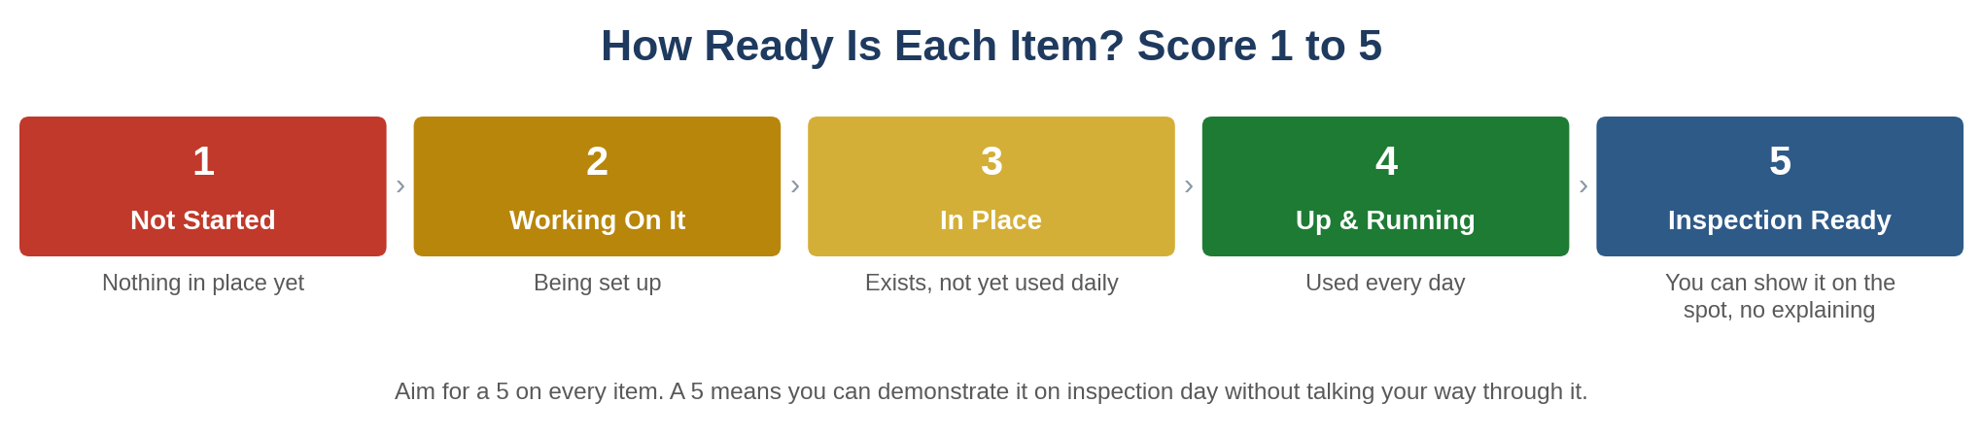
Circle one number per item. 1 = nothing in place yet, 2 = working on it, 3 = in place but not used daily, 4 = up and running, 5 = you can show it on the spot with no explaining. Anything scoring 3 or below on a critical item means you are not ready to schedule.
WHAT THIS MEANS FOR YOU
Score what you can actually show, not what you have bought or written down. A camera system that records but cannot pull up a clip when asked is a 3, not a 5. That gap — between “we have it” and “we can prove it” — is exactly what the inspection is designed to find.

A.1 Tax, Facility & Property
Control | 1 | 2 | 3 | 4 | 5
The license holder is not included on the most recent monthly Minnesota Department of Revenue notice for “Posting of Tax Delinquency.” [M.S. § 270C.726, subd. 1] | ○ | ○ | ○ | ○ | ○
The business has a method to ensure it does not make sales or deliveries to another licensee included on the most recent Department of Revenue tax-delinquency posting. [M.S. § 270C.726, subd. 2] | ○ | ○ | ○ | ○ | ○
The building has a certificate of occupancy. If it does not, one of the following is true: the municipality has waived the requirement; the applicant holds a letter or certification from the municipality that a certificate is not required; the applicant holds a letter or certification from the municipality or a third-party certifier that the building meets all codes; or the building is exempt under an “agricultural building” designation. [M.R. 9810.1100, subp. 6(B)] | ○ | ○ | ○ | ○ | ○
At least one toilet facility is located on the premises in a completely enclosed room with a tight-fitting, self-closing door. [M.R. 9810.1100, subp. 6(A)] | ○ | ○ | ○ | ○ | ○
The product storage area allows regulated products to be stored at least six inches above the ground. [M.R. 9810.1104, subp. 2] | ○ | ○ | ○ | ○ | ○
The product storage area is clean, well ventilated, and free from condensation, sewage, dust, dirt, pests, chemicals, and other contaminants. [M.R. 9810.1104, subp. 2] | ○ | ○ | ○ | ○ | ○
The product storage area is locked. [M.R. 9810.1104, subp. 3] | ○ | ○ | ○ | ○ | ○
The product storage area has a posted sign at the entrance stating “Restricted access. Authorized personnel only.” [M.R. 9810.1104, subp. 3] | ○ | ○ | ○ | ○ | ○
Hand-washing facilities have a hot and cold water supply. [M.R. 9810.2102, subp. 10(A)(2)(a)] | ○ | ○ | ○ | ○ | ○
Hand-washing facilities include soap and paper towels, sanitary towel service, or an electric hand dryer. [M.R. 9810.2102, subp. 10(A)(2)(b–c)] | ○ | ○ | ○ | ○ | ○
A ventilation and air-handling system provides humidity and temperature controls adequate for safe processing and sanitary operations. [M.R. 9810.2102, subp. 6(A)(3)] | ○ | ○ | ○ | ○ | ○

A.2 Security & Access Control
Control | 1 | 2 | 3 | 4 | 5
Security at the premises includes, at minimum, an alarm system, video surveillance, lighting, and locks, plus an immediate response protocol initiated within 30 minutes after a security event occurs. [M.R. 9810.1500, subps. 1(A), 2(A)(1–5)] | ○ | ○ | ○ | ○ | ○
Effective security measures guard against product theft. [M.R. 9810.1500, subp. 5(A)] | ○ | ○ | ○ | ○ | ○
Effective security measures guard against product diversion. [M.R. 9810.1500, subp. 5(B)] | ○ | ○ | ○ | ○ | ○
Effective security measures guard against unauthorized access to the premises. [M.R. 9810.1500, subp. 7(A)] | ○ | ○ | ○ | ○ | ○
Effective security measures guard against unauthorized access to motor vehicles used in the transport or delivery of cannabis or cannabis products. [M.R. 9810.1500, subp. 7(B)] | ○ | ○ | ○ | ○ | ○
Effective security measures guard against unauthorized access to electronic business and customer records created and maintained by the business. [M.R. 9810.1500, subp. 7(C)] | ○ | ○ | ○ | ○ | ○
Effective security measures guard against unauthorized access to paper records created and maintained by the business. [M.R. 9810.1500, subp. 7(D)] | ○ | ○ | ○ | ○ | ○
The alarm system is in good working order. [M.R. 9810.1500, subp. 8(A)] | ○ | ○ | ○ | ○ | ○
The alarm system is active 24 hours per day, seven days per week. [M.R. 9810.1500, subp. 8(A)] | ○ | ○ | ○ | ○ | ○
The alarm system is monitored by a contracted security company or a worker employed by the business. [M.R. 9810.1500, subp. 8(A)] | ○ | ○ | ○ | ○ | ○
The alarm provides immediate alerts to the business and local law enforcement for any unauthorized breach of the premises or a system failure. [M.R. 9810.1500, subp. 8(A)(1)] | ○ | ○ | ○ | ○ | ○
The alarm provides immediate alerts to the business and local law enforcement for any hazardous conditions detected on the premises. [M.R. 9810.1500, subp. 8(A)(2)] | ○ | ○ | ○ | ○ | ○
The alarm has a backup system that activates immediately and automatically upon loss of electricity and alerts authorized personnel of the loss. [M.R. 9810.1500, subp. 8(A)(3)] | ○ | ○ | ○ | ○ | ○
The alarm includes an audible alarm capable of being heard by an individual within a 100-foot radius of entrances and exits. [M.R. 9810.1500, subp. 8(A)(4)] | ○ | ○ | ○ | ○ | ○
The audible alarm can be remotely disabled by authorized personnel. [M.R. 9810.1500, subp. 8(A)(5)] | ○ | ○ | ○ | ○ | ○
An operational video surveillance system is present on the premises. [M.R. 9810.1500, subp. 9(A)] | ○ | ○ | ○ | ○ | ○
The surveillance system is active 24 hours per day, seven days per week. [M.R. 9810.1500, subp. 9(B)] | ○ | ○ | ○ | ○ | ○
Cameras are placed to allow clear recording of activity within a radius of at least 20 feet from all points of entry and exit. [M.R. 9810.1500, subp. 9(C)(1)] | ○ | ○ | ○ | ○ | ○
Cameras are affixed to the exterior and interior of the premises to identify individuals entering and exiting the premises, limited-access areas, and restricted-access areas. [M.R. 9810.1500, subp. 9(C)(2)] | ○ | ○ | ○ | ○ | ○
The system allows viewing of all areas where cannabis is cultivated, manufactured, stored, packaged and labeled, prepared for transfer, displayed, sold, where samples are collected, or where waste is destroyed or made unusable. [M.R. 9810.1500, subp. 9(D)] | ○ | ○ | ○ | ○ | ○
Video files are stored in a secure place for a minimum of 90 days. [M.R. 9810.1500, subp. 9(E)(1)] | ○ | ○ | ○ | ○ | ○
Cameras record at a minimum of 15 frames per second. [M.R. 9810.1500, subp. 9(E)(2)] | ○ | ○ | ○ | ○ | ○
Cameras have a minimum resolution of 720p. [M.R. 9810.1500, subp. 9(E)(3)] | ○ | ○ | ○ | ○ | ○
All recordings carry date and time stamps. [M.R. 9810.1500, subp. 9(E)(4)] | ○ | ○ | ○ | ○ | ○
Cameras can continue recording for an additional eight hours during a power outage. [M.R. 9810.1500, subp. 9(E)(5)] | ○ | ○ | ○ | ○ | ○
Recordings are saved in an industry-standard file format that can be played without the purchase of particular software or equipment. [M.R. 9810.1500, subp. 9(F)(2)] | ○ | ○ | ○ | ○ | ○
Fully functioning lighting is present in the interior and exterior of the premises. [M.R. 9810.1500, subp. 10] | ○ | ○ | ○ | ○ | ○
Lighting permits observers to see, and cameras to record, any activity within a radius of at least 20 feet around all entrances and exits. [M.R. 9810.1500, subp. 10] | ○ | ○ | ○ | ○ | ○
All external entrances and perimeter windows are in good condition, verified by visual inspection inside and out. [M.R. 9810.1500, subp. 12] | ○ | ○ | ○ | ○ | ○
All external entrances and perimeter windows are lockable with commercial-grade locks. [M.R. 9810.1500, subp. 12] | ○ | ○ | ○ | ○ | ○
All perimeter entry doors have electronic locks and keypads. [M.R. 9810.1500, subp. 12] | ○ | ○ | ○ | ○ | ○
Any outdoor cultivation areas are enclosed by secure fencing and locked gates. [M.R. 9810.1500, subp. 15] | ○ | ○ | ○ | ○ | ○
Any outdoor cultivation areas are enclosed by fencing that is at least six feet high. [M.R. 9810.1500, subp. 15] | ○ | ○ | ○ | ○ | ○
Any outdoor cultivation areas are enclosed by fencing that obscures — or have a cover that obscures — the fenced area from being readily viewed from outside the fenced area. [M.R. 9810.1500, subp. 15] | ○ | ○ | ○ | ○ | ○
Any outdoor cultivation areas are enclosed by fencing that is commercial or security grade. [M.R. 9810.1500, subp. 15] | ○ | ○ | ○ | ○ | ○

A.3 Personnel & Operations
Control | 1 | 2 | 3 | 4 | 5
No employee under 21 years of age has a scope of work involving the handling of cannabis plants, cannabis flower, artificially derived cannabinoids, or cannabinoid products. [M.S. § 342.24, subd. 1(a)] | ○ | ○ | ○ | ○ | ○
The business has an annual training plan. [M.R. 9810.1100, subp. 2A(2)] | ○ | ○ | ○ | ○ | ○
No licensed activity is conducted in a dwelling (home or residence). [M.R. 9810.1100, subp. 4] | ○ | ○ | ○ | ○ | ○
The business has a measuring device or equipment (scale). [M.R. 9810.1100, subp. 7] | ○ | ○ | ○ | ○ | ○
All weighing and measuring equipment is maintained in a sanitary manner that does not contaminate any products. [M.R. 9810.1100, subp. 7] | ○ | ○ | ○ | ○ | ○
All electrical equipment, including grow lights, cultivation equipment, and packaging equipment, is suitable for the intended use. [M.R. 9810.2000, subp. 8(C)] | ○ | ○ | ○ | ○ | ○
Each production and cultivation area allows authorized individuals unobstructed access to, observation of, and the ability to conduct an inventory of all plant canopy. [M.R. 9810.2000, subp. 8(D)] | ○ | ○ | ○ | ○ | ○
Crop inputs are stored in their original containers with original labels intact, or in working containers of diluted or prepared applications labeled with the information required by Minnesota Statutes, chapters 18B, 18C, and 18D. [M.R. 9810.2000, subp. 11(A)(3)] | ○ | ○ | ○ | ○ | ○
If the business cultivates adult-use and medical cannabis on the same premises, the cultivation areas are separate from one another. [M.R. 9810.2000, subp. 14(B)(1)] | ○ | ○ | ○ | ○ | ○
Total plant canopy is 30,000 sq ft indoor / 2 acres outdoor or less. [M.S. § 342.30, subd. 2(a–b)] | ○ | ○ | ○ | ○ | ○

A.4 SOPs, Records & Metrc
Control | 1 | 2 | 3 | 4 | 5
SOP: worker safety procedures compliant with Minnesota Rules, part 9810.1102. [M.R. 9810.1100, subp. 2A(3)] | ○ | ○ | ○ | ○ | ○
SOP: creation and entry of accurate data in the statewide monitoring system. [M.R. 9810.1100, subp. 2(A)(4)] | ○ | ○ | ○ | ○ | ○
SOP: safe and sanitary storage of cannabis plants, cannabis flower, and cannabis products, including maintaining the cleanliness of any building or equipment used to store or display them. [M.R. 9810.1100, subp. 2(A)(5)] | ○ | ○ | ○ | ○ | ○
SOP: proper segregation and disposal of a regulated product that is damaged, has a broken seal, has been contaminated, has not been sold by the expiration date on the label, or is the subject of a recall. [M.R. 9810.1100, subp. 2(A)(6)] | ○ | ○ | ○ | ○ | ○
SOP: proper designation of authorized personnel for specified duties and the procedure for issuing worker identification for restricted-access areas. [M.R. 9810.1100, subp. 2(A)(7)] | ○ | ○ | ○ | ○ | ○
SOP: proper designation of authorized personnel with authority to access, enter, and update private and nonpublic computer data. [M.R. 9810.1100, subp. 2(A)(8)] | ○ | ○ | ○ | ○ | ○
SOP: responding to a security breach, consistent with Minnesota Statutes, chapters 325E.61 and 325E.64. [M.R. 9810.1100, subp. 2(A)(9)] | ○ | ○ | ○ | ○ | ○
Written procedures ensure the consistent and accurate use of weighing and measuring equipment for mandatory controls and the accurate entry of weights and measurements into the statewide monitoring system. [M.R. 9810.1100, subp. 7] | ○ | ○ | ○ | ○ | ○
SOP (if applicable): providing representative samples of the business’s cannabis plants, cannabis flower, and cannabis products for testing. [M.R. 9810.1100, subp. 2A(10)] | ○ | ○ | ○ | ○ | ○
SOP: reporting all potential substances used during cultivating, manufacturing, and packaging processes to the statewide monitoring system for batch safety testing. [M.R. 9810.1100, subp. 2A(11)] | ○ | ○ | ○ | ○ | ○
The business has procedures for storing regulated products in a controlled environment, ensuring products are free from contamination. [M.R. 9810.1104, subp. 1] | ○ | ○ | ○ | ○ | ○
Storage procedures ensure product storage areas are used only for the storage of regulated products. [M.R. 9810.1104, subp. 1(A)] | ○ | ○ | ○ | ○ | ○
Records describe the date and time of each occasion when a product storage area was accessed, by whom, the name of the individual, and the products added to or removed from the storage area. [M.R. 9810.1104, subp. 1(B)] | ○ | ○ | ○ | ○ | ○
Records are maintained for the names and log-in credentials of all Metrc system administrators and system users who have had access within the past 12 months. [M.R. 9810.1301, subp. 8] | ○ | ○ | ○ | ○ | ○

A.5 Workforce Training
Control | 1 | 2 | 3 | 4 | 5
Each cannabis worker receives annual training that applies to the role, authority, and responsibilities of that worker. [M.R. 9810.1102, subp. 2(B)] | ○ | ○ | ○ | ○ | ○
Annual training includes the SOPs required under M.R. 9810.1100, subp. 2A. [M.R. 9810.1102, subp. 2(B)(1)] | ○ | ○ | ○ | ○ | ○
Annual training includes state and federal cannabis laws. [M.R. 9810.1102, subp. 2(B)(2)] | ○ | ○ | ○ | ○ | ○
Annual training includes state and federal laws regarding data privacy and confidentiality. [M.R. 9810.1102, subp. 2(B)(3)] | ○ | ○ | ○ | ○ | ○
Annual training includes the proper use of security measures and controls adopted in compliance with M.R. 9810.1500 and M.S. chapter 342. [M.R. 9810.1102, subp. 2(B)(4)] | ○ | ○ | ○ | ○ | ○
Annual training includes procedures for responding to an emergency, including a fire, loss of electrical power, robbery, natural disaster, and workplace violence. [M.R. 9810.1102, subp. 2(B)(5)] | ○ | ○ | ○ | ○ | ○
Annual training includes product recall procedures. [M.R. 9810.1102, subp. 2(B)(6)] | ○ | ○ | ○ | ○ | ○
Records are maintained containing information about each worker who conducts activities authorized by the office, including records that the worker completed the necessary training. [M.R. 9810.1102, subp. 2(D)] | ○ | ○ | ○ | ○ | ○
Each worker is provided with information about hazardous materials that may be present on the premises. [M.R. 9810.1102, subp. 3(C)] | ○ | ○ | ○ | ○ | ○
Each worker is provided with information about procedures for safely handling and operating equipment or tools. [M.R. 9810.1102, subp. 3(D)] | ○ | ○ | ○ | ○ | ○

A.6 Sampling & Testing
Control | 1 | 2 | 3 | 4 | 5
The business has an SOP describing how to collect a representative sample for each regulated product. [M.R. 9810.1100, subp. 2A(10)] | ○ | ○ | ○ | ○ | ○
The sampling SOP addresses all requirements for sample and data collection and laboratory analysis. [M.R. 9810.3100, subp. 3A(1)] | ○ | ○ | ○ | ○ | ○
The sampling SOP contains the details necessary for accurate and consistent actions by assigned staff. [M.R. 9810.3100, subp. 3A(2)] | ○ | ○ | ○ | ○ | ○
The sampling SOP describes all processes for supervisors to verify that sample collection procedures are completed accurately by staff. [M.R. 9810.3100, subp. 3A(3)] | ○ | ○ | ○ | ○ | ○
Records for training of staff conducting sampling activities or sample testing are maintained for three years. [M.R. 9810.3100, subp. 3B] | ○ | ○ | ○ | ○ | ○

Reading your scores. Add up each section and see where you stand. You are not ready to schedule while any critical item is still below a 5. Score yourself now, fix what is low, then score again after your practice inspection.

Appendix B — Mock Inspector Script
Use this to run a practice inspection before the real one. Have someone play the inspector and read these prompts out loud, working through the layers in order. For each one, the test is the same: can the business answer from its systems and its people, without the owner narrating?

Layer 1 — Environmental Control
- “Walk me from the public entrance to where regulated product is stored. Stop at every door that should be controlled.”
- “Show me the boundary between general areas and limited-access areas.”
- “Which entrances are marked restricted, and what does the signage say?”
- “Show me the product storage area. Is it locked, and is the restricted-access sign posted?”
- “Walk me the perimeter of any outdoor cultivation area. Show me the fence height, the gate lock, and how the area is obscured from outside view.”
Pass condition: no uncontrolled path between general and restricted zones; signage present and correct; storage locked.

Layer 2 — System Independence
- “Pull up the live inventory for an item I will name. I want to see the screen, not a printout.”
- “Retrieve last night's camera footage for the storage-room door.”
- “Show me the access log for the restricted area for the past week.”
- “Show me your list of Metrc administrators and users with access in the past 12 months.”
Pass condition: the on-duty worker performs each retrieval without summoning a manager or vendor.

Layer 3 — Traceability Drill
- “Select this plant. Show me its batch number, its source, every crop input applied to it with weight and concentration, and who worked on it and when.”
- “Reconstruct one harvested batch end to end: initiation of cultivation, maintenance and culling, harvest date, and current status.”
- “Show me where a destroyed or wasted plant is recorded.”
Pass condition: complete lifecycle from the system alone; no manual reconstruction or external document required.
WHAT THIS MEANS FOR YOU
If you only have time to practise one thing, practise this. A business that cannot trace one item on demand will not pass, no matter how good everything else looks. Pick something at random and trace it, today.

Layer 4 — Staff Behavioural Audit
Question each on-duty worker individually, without warning.
- “How do you handle an inventory discrepancy you discover mid-shift?”
- “What do you do before applying a crop input, and what do you record afterwards?”
- “Who do you notify, and in what order, during a security breach?”
- “What do you do if the alarm or camera system goes down?”
- “Where are the written procedures, and can you show me one right now?”
- “What training have you had in the past 12 months, and where is it recorded?”
Pass condition: consistent answers across staff; no reliance on a supervisor for basic compliance actions; nobody under 21 handling regulated product.

Layer 5 — Plan and SOP Integration
- “Show me your written procedure for [scenario], then show me how it is actually executed today.”
- “Show me your cultivation plan. Now walk me the site against it — canopy diagram, ventilation, waste, propagation source, drying and curing.”
Pass condition: observed practice matches the written SOP and the filed plan. Any divergence is a documentation-versus-reality finding — the most serious failure mode.

Appendix C — Evidence Request List
Gather these before your practice inspection, and again before the real one. Having the actual documents and systems ready — not just descriptions of them — is what separates a business that is ready from one that merely believes it is.
❑ Certificate of occupancy, or municipal waiver / code letter / agricultural building exemption
❑ Executed lease or deed; site plan with control zones marked
❑ Municipal zoning confirmation; building and fire code confirmation
❑ Ownership disclosure, capitalization table, operating agreement (reconciled to each other)
❑ Source-of-funds documentation and fund-flow narrative
❑ Security plan; alarm and camera specification sheets; vendor contracts
❑ 90-day surveillance retention confirmation and a live sample retrieval
❑ Security testing log (90-day cycle) and any repair records
❑ Restricted-area access log demonstrating three-year retention capability
❑ Metrc administrator and user list covering the past 12 months
❑ Live Metrc access for a traceability drill
❑ Complete SOP library (every required procedure)
❑ Written weighing and measuring procedures; scale and calibration records
❑ Worker training records and the annual training curriculum
❑ Confirmation that no worker under 21 handles regulated product
❑ DOR tax-status confirmation (not on the delinquency posting) and your method for screening counterparties
❑ Cultivation plan as filed, plus any change notifications sent to OCM
❑ Canopy diagram with distinct cultivation areas measured
❑ Crop input vendor invoices, labels, and application records
❑ Cultivation records for each batch (five-year retention)
❑ Propagation source documentation from an OCM-authorised source
❑ Integrated pest management protocol
❑ Sampling SOP with supervisor verification step
❑ Sampler training records (three-year retention)
❑ Labor peace agreement attestation

Appendix D — Corrective Action Plan
One page per problem you find. Whenever your checklist or practice inspection turns up a gap, write it down here with who is fixing it and by when. This is how you make sure nothing slips through before you schedule.
Severity | Definition
Critical | Likely to result in inspection failure. Submission-blocking.
Major | May result in a deficiency notice. Resolve before submission.
Minor | Improvement recommended; unlikely to block on its own.
Observation | Best-practice recommendation.

Finding Record
Finding number: __________________________________________________________
Description: __________________________________________________________
Which checklist item (from Appendix A): __________________________________________________________
Which endorsement module it sits in: __________________________________________________________
How serious (Critical / Major / Minor / Observation): __________________________________________________________
Corrective action: __________________________________________________________
Responsible party: __________________________________________________________
Target date: __________________________________________________________
Completion date: __________________________________________________________
Verification method: __________________________________________________________
WHAT THIS MEANS FOR YOU
Fix the critical items first, even if they are harder. One open critical item keeps you “not ready” no matter how many small things you have checked off. It is tempting to knock out the easy wins — do them, but do not mistake them for progress on the things that actually decide the outcome.

Appendix E — After-Action Report Template
Fill this in after your practice inspection. It is a clean, one-page summary of where you stand — something you can hand to a business partner, an investor, or a lender to show you have done the work and know exactly what is left.
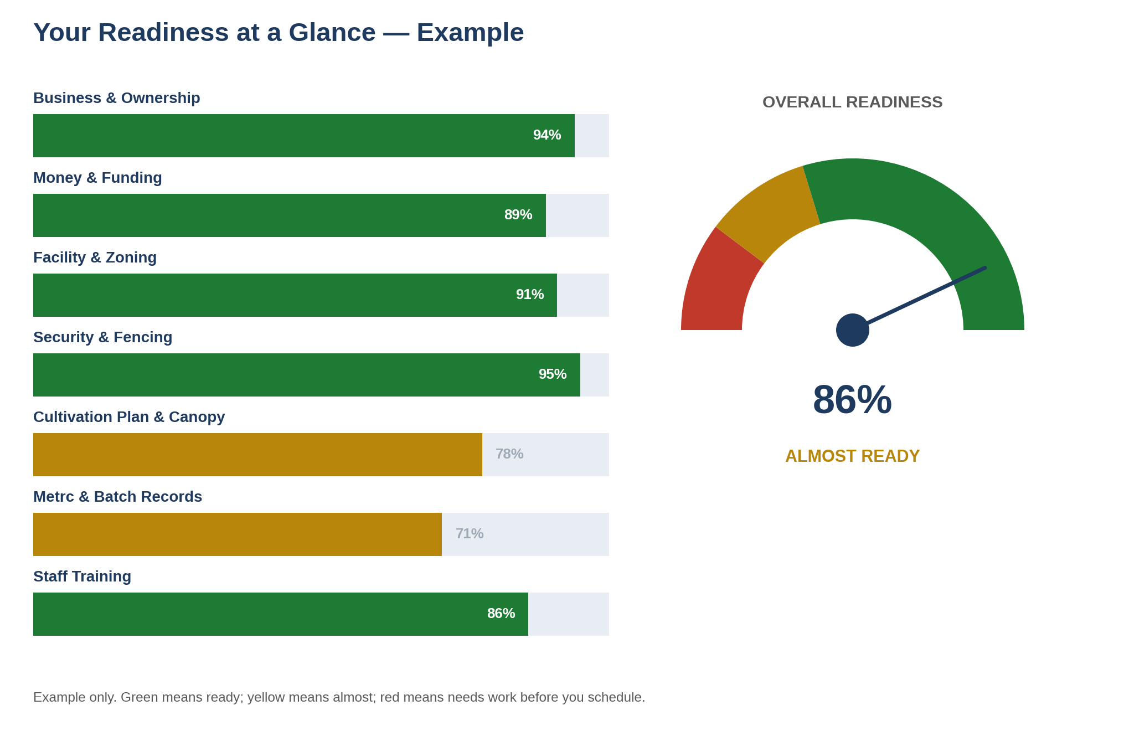

Report Fields
Business name: __________________________________________________________
Licence type: __________________________________________________________
Endorsements held or applied for: __________________________________________________________
Site address: __________________________________________________________
Assessment date: __________________________________________________________
Assessed by: __________________________________________________________
Composite readiness score: __________________________________________________________
Classification (GREEN / YELLOW / RED): __________________________________________________________

Areas of Strength
1: __________________________________________________________________
2: __________________________________________________________________
3: __________________________________________________________________

Areas for Improvement
1: __________________________________________________________________
2: __________________________________________________________________
3: __________________________________________________________________

Domain Scorecard
Domain | Score | Status
Entity Compliance & Ownership |  | ☐ Pass ☐ Improve
Financial Documentation |  | ☐ Pass ☐ Improve
Facility Readiness & Local Approval |  | ☐ Pass ☐ Improve
Security Systems |  | ☐ Pass ☐ Improve
Inventory Controls (Metrc) |  | ☐ Pass ☐ Improve
SOPs & Recordkeeping |  | ☐ Pass ☐ Improve
Staff Training |  | ☐ Pass ☐ Improve
Cultivation Plan & Canopy |  | ☐ Pass ☐ Improve
Sampling & Testing |  | ☐ Pass ☐ Improve

Recommendations & Next Review
Priority recommendations: __________________________________________________________
Recommended next mock inspection date: ____________________________________________
Validity. A readiness assessment reflects conditions observed on the assessment date. Staffing, facility, SOP, plan, or regulatory changes after that date may materially affect readiness. CannaPath recommends reassessment before scheduling your OCM inspection and after any material change to your site or plans.

Important Notice & Disclaimer
This workbook is provided by CannaPath Compliance & Regulatory Solutions for informational and educational purposes only. It is not legal advice and does not create an attorney-client relationship. It does not replace independent legal, financial, engineering, or technical advice appropriate to your circumstances.
Using this workbook does not guarantee any particular lottery result, licensing decision, or inspection outcome — all of those rest solely with the Minnesota Office of Cannabis Management. CannaPath is not affiliated with, endorsed by, or acting on behalf of OCM or any other state agency.
Any readiness assessment you complete using this workbook represents your own or an independent professional assessment of operational readiness. It is not an endorsement, approval, certification, or pre-clearance by OCM and carries no weight in any OCM determination.
The field checklist is derived from OCM's published Cannabis Cultivator Pre-License Inspection List (updated May 19, 2026) and the underlying provisions of Minnesota Rules, chapter 9810, and Minnesota Statutes, chapter 342. OCM states that its list may not be exhaustive of all items the office will inspect, and that the office is authorised to inspect the entire premises of a cannabis business.
Statutory text referenced here is drawn from the 2025 Minnesota Statutes as published by the Office of the Revisor of Statutes, together with OCM's published summary of the changes enacted in the 2026 regular session (SF 4401 / 2026 Session Laws, chapter 123). Several 2026 provisions carry effective dates of August 1, 2026 or January 1, 2027. Deadlines, fees, canopy limits, and endorsement rules change. Verify every figure and every citation directly with OCM and with your own counsel before relying on it.
The reconsideration procedure described in this workbook reflects OCM's published Application Reconsideration Process as of the date of this manual. The 14-day deficiency-cure window is reported per OCM guidance and should be confirmed against the notice you actually receive.

© 2026 CannaPath Compliance & Regulatory Solutions. All rights reserved.
Confidential — Prepared for Prospective Minnesota Cannabis Cultivator Licensees

